Prospective life cycle analysis of green platform chemicals uncovers their full environmental potential
Abhinandan Nabera,ª Ioan-Robert Istrate,^{b} Antonio José Martín,ª Javier Pérez-Ramírez,^{a,}* Gonzalo Guillén-Gosálbez^{a,}*
ªDepartment of Chemistry and Applied Biosciences, ETH Zurich, 8093 Zurich, Switzerland
^{b}Institute of Environmental Sciences (CML), Leiden University, 2333 CC Leiden, The Netherlands
*jpr@chem.ethz.ch, gonzalo.guillen.gosalbez@chem.ethz.ch
Abstract
Conventional routes for producing chemicals, such as ammonia and methanol, heavily rely on fossil-based catalytic processes. Recently, emerging technologies have played a pivotal role in advancing low-carbon production pathways for these chemicals. However, proposed climate policies have set ambitious targets that entail transformations in the economic landscape, including transportation systems and the decarbonization of energy. Disregarding these shifts when assessing the environmental performance of chemical production could lead to spurious conclusions. Hence, in this study, we conduct a prospective life cycle assessment (LCA) until 2050 within the framework of climate policies aiming to limit global temperature rise to 1.5 °C or 2 °C across 26 regions worldwide. Our findings reveal that green pathways for ammonia and methanol production exhibit a significant reduction in environmental impacts by 2050 compared to their fossil-based counterparts, with solar-based routes being the most beneficial. Overall, this study will guide stakeholders in making optimal decisions, accelerating the shift towards a sustainable chemical industry.
Keywords: climate policies, platform chemicals, prospective life cycle assessment.
  - Introduction
The chemical industry poses a formidable challenge towards decarbonization, primarily due to its heavy reliance on fossil fuels, leading to 5.6 Gt CO₂-eq, accounting for 10% of global GHG emissions (Bauer et al., 2023). Moreover, only one-third of these emissions are direct, with the remaining attributed to energy acquisition and the upstream value chain, highlighting the industry’s dependence on global energy systems and supply chains. However, this challenge also presents an opportunity to reduce a significant portion of the environmental impacts associated with chemical production through decarbonization efforts in other key sectors. In recent times there have been rapid technological advancements in response to decarbonization challenges and climate policies aligned with the goals set by the Paris Agreement. In this context, key platform chemicals such as ammonia and methanol play a crucial role in reducing emissions due to their large production volumes and diverse applications. Historically, several studies have evaluated low-carbon production routes for both ammonia and methanol utilizing renewable carbon and hydrogen-based feedstocks (D’Angelo et al., 2021). These analyses have consistently highlighted the environmental superiority of green routes over their fossil counterparts. However, the majority of these LCA studies often assume that chemical production occurs under the existing energy system and supply chains, neglecting forthcoming decarbonization efforts. Therefore, disregarding a comprehensive analysis of chemical production in the context of a decarbonizing global economy could lead policymakers and stakeholders to make suboptimal decisions. Hence, in this work, we evaluate the environmental impacts of fossil and green ammonia and methanol pathways until 2050. We particularly consider anticipated changes in power, materials, and transportation sectors under three climate scenarios: a baseline scenario (3.5 °C), and two scenarios aiming to limit global warming below 2 °C and 1.5 °C, respectively. Furthermore, we highlight the significance of locations in decision-making, by performing a temporal region-specific prospective LCA for 26 regions worldwide. Our results provide a broader perspective on the environmental performance of various chemical production methods, highlighting the sustainability potential of both fossil and renewable carbon-based chemicals under plausible future socio-economic and technological scenarios.
  - Methods
We employ the IMAGE Integrated Assessment Model (IAM) to evaluate the environmental performance of both fossil and green pathways for ammonia and methanol production. This enables us to project potential economic scenarios and provide insights into the environmental impacts based on expected socio-economic and technological advancements. Specifically, we adopt the middle-of-the-road shared socio-economic pathway (SSP2) and consider a range of representative concentration pathways (RCPs), including RCP6, RCP2.6, and RCP1.9, to create various scenarios reflecting economic shifts. RCP6 corresponds to a scenario limiting global temperature rise to 3.5 °C, while RCP2.6 and RCP1.9 correspond to scenarios limiting temperature rise to 2 °C and 1.5 °C, respectively. To generate inventories for prospective LCAs covering the time period from 2020 to 2050, we utilize the premise v1.5.9 framework (Sacchi et al., 2022). Additionally, we incorporate the temporal dimension for the production of these platform chemicals across 26 global regions, considering location-specific temporal dynamics.
  - Results and Discussions
Compared to fossil-based methods, the projected climate change impacts of ammonia production through solar and wind-based routes, (taken herein to illustrate this study, Figure 1a), display a promising trajectory, indicating substantial reductions by 2050. Under more aggressive policies, such as the 1.5 °C scenario, these impacts are expected to decrease significantly. Specifically, both the solar and wind-based pathways are projected to exhibit approximately a 70% reduction in impacts by 2050. Furthermore, a regional assessment reveals that impact reductions vary significantly by region for both solar (Figure 1b) and wind-based (Figure 1c) ammonia production, highlighting the crucial role of location-specific dynamics necessary for strategic planning to maximize global benefits.
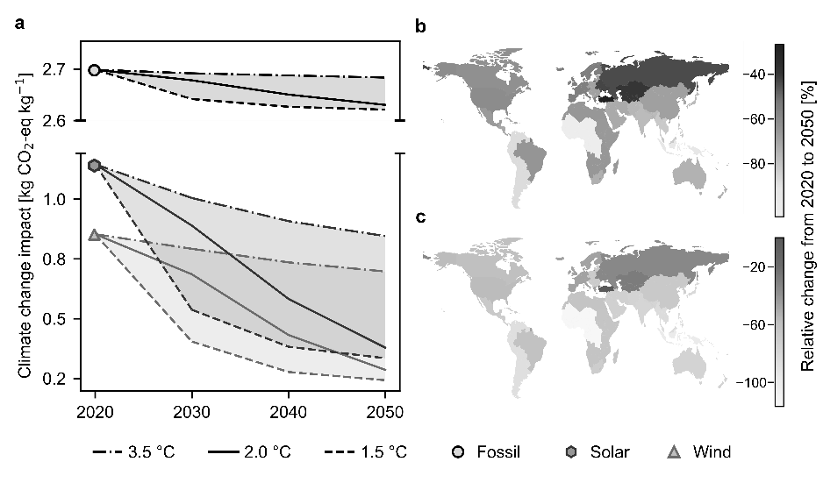
Figure 1 Climate change impacts of ammonia production technologies. (a) Global average impacts of fossil, solar and wind-based production from 2020 to 2050 across three scenarios (3.5 °°C, 2 C, and 1.5 °C). Regional analysis under the 2 °C scenario for (b) solar and (c) wind-based production pathways.
  - Conclusions
In this work, we assess the impact of climate policies on key platform chemicals like ammonia and methanol across 26 regions spanning from 2020 to 2050 under three climate policy scenarios. Notably, we find that fossil production routes exhibit insignificant improvements in their climate change impacts due to their heavy dependence on fossil fuels, while green pathways, particularly solar-based technologies, show significant reductions which are further magnified under ambitious climate policies. We also highlight the dynamic nature of these technologies with their rankings changing over time and regional variations in impact reductions. This necessitates the implementation of tailored approaches based on regional energy profiles. Overall, this work underscores the importance of considering technological advancements, market dynamics, and regional considerations to achieve low-carbon chemical production. This study will guide stakeholders, including policymakers, industry leaders, and investors towards making informed-decisions and achieving the transition towards a sustainable chemical industry.
References
Bauer, F., Tilsted, J.P., Pfister, S., Oberschelp, C., Kulionis, V., 2023. Mapping GHG emissions and prospects for renewable energy in the chemical industry. Curr. Opin. Chem. Eng. 39, 100881.
D’Angelo, S.C., Cobo, S., Tulus, V., Nabera, A., Martín, A.J., Pérez-Ramírez, J., Guillén-Gosálbez, G., 2021. Planetary Boundaries Analysis of Low-Carbon Ammonia Production Routes. ACS Sustain. Chem. Eng. 9, 9740–9749.
Sacchi, R., Terlouw, T., Siala, K., Dirnaichner, A., Bauer, C., Cox, B., Mutel, C., Daioglou, V., Luderer, G., 2022. PRospective EnvironMental Impact asSEment (premise): A streamlined approach to producing databases for prospective life cycle assessment using integrated assessment models. Renew. Sustain. Energy Rev. 160, 112311.

